**M S Ramaiah Institute of Technology**

(An Autonomous Institute, Affiliated to VTU)

MSR nagar, MSRIT post, Bangalore-54

**A Mid-Sem Evaluation Report on**

**Smart Health care monitoring system using Raspberry pi**

Submitted by

Himanshu Kumar 1MS12CS039

Suhail T N 1MS12CS115

Manoj more S 1MS13CS412

Suresh V 1MS13CS421

Under the guidance of

**Mrs. S. Rajarajeswari**

Assistant Professor

Dept of Computer Science & Engg.

M S Ramaiah Institute of Technology.



**DEPARTMENT OF COMPUTER SCIENCE & ENGINEERING**

**M.S.RAMAIAH INSTITUTE OF TECHNOLOGY**

**(Autonomous Institute, Affiliated to VTU)**

**BANGALORE-560054**

[www.msrit.edu](http://www.msrit.edu)

**Abstract**

Monitoring healthcare in current generation is to be given an utmost importance. Diseases are the brutal hurdles to human beneficiary. One amongst the brutal illnesses is the Alzheimer’s and Quadriplegia (paralysis due to which all four limbs are affected). People suffering from Alzheimer’s disease tend to forget everything including their own identity, location and their kith and kin’s and people suffering from Quadriplegia sometimes cannot breathe properly and during this time their heart beat may go low or they may be uncomfortable at this time. In order to minimize the difficulties of people who are suffering from Alzheimer or Quadriplegia, we propose a method to locate such person and tracking vitals such has heart beat and body temperature to ensure better care of patient in critical situation. We achieve the monitoring of health care of affected individuals by an android to show varying heart beat and temperature. The process involves generation of patient heart beat and body temperature using appropriate Sensor that are embedded on the Raspberry pi board. We have also added AWS (Amazon web service), where the data generated are send to the server that is created using EC2 (Elastic compute Generation 2) AWS service and later this stored data is send to the Android Application. Sensors embedded in the environment are used to collect behavior and activity patterns for the purpose of detecting health changes. Early detection is the key to promoting health, independence, and function as people age.

**TABLE OF CONTENTS**

|  |  |  |
| --- | --- | --- |
| **Sl. No.** | **Topic** | **Page No** |
| 1. | Synopsis | 4 - 10 |
| 2. | Project Plan | 11 – 21 |
| 3. | Software Requirement Specification. | 22 – 30 |
| 4. | Literature Survey. | 31 – 36 |
| 5. | Design Document. | 37 - 50 |
| 6. | Reference | 51 |

**M S Ramaiah Institute of Technology**

(An Autonomous Institute, Affiliated to VTU)

MSR nagar, MSRIT post, Bangalore-54

A synopsis on

**Smart Health Care Monitoring System using Raspberry Pi.**

Under the guidance of

**Mrs. S. Rajarajeswari**

Submitted by

Himanshu Kumar 1MS12CS039

Suhail T N 1MS12CS115

Manoj more S 1MS13CS412

Suresh V 1MS13CS421

*In partial fulfillment for the award of the degree of*

# *Bachelor of Engineering in Computer Science & Engineering*



**DEPARTMENT OF COMPUTER SCIENCE & ENGINEERING**

**M.S.RAMAIAH INSTITUTE OF TECHNOLOGY**

**(Autonomous Institute, Affiliated to VTU)**

**BANGALORE-560054**

[www.msrit.edu](http://www.msrit.edu)

**TABLE OF CONTENTS**

1. Introduction
2. Motivation
3. Objective(s) and Scope
4. Description of the proposed project work/ Methodology
5. Conclusions
6. Future scope

# Introduction

The people suffering from Alzheimer diseases usually forget everything including about their own identify location and their near and dear people. Hence this project proposed a method to help to locate Alzheimer patients when they venture outdoors. Also in the proposed project the Alzheimer patient health is monitored for heart monitoring and body temperature, so this data can be accessed by the android application.

# Motivation

Nowadays GPS and RFID tags are available which can be effectively used to locate devices and people easily. This project proposes one of such method to address the lost Alzheimer patients and inform about their locations to near and dear. Also by tracking the health parameters of patients their well being is monitored and timely action can be taken.

**Problem of Statement**

* Many older people forget someone’s name or misplace things from time to time. This kind of forgetfulness is normal.
* But, forgetting how to get home, getting confused in places a person knows well, or asking questions over and over can be signs of a more serious problem.
* The person may have Alzheimer’s disease. It is a disease of the brain that begins slowly and gets worse over time.
* What is the current Heart Rate, temperature is difficult to monitor manually for this type of person.

# Objective(s) and Scope

This method proposes to locate Alzheimer patients using RFID tags and GPS data. For this we propose a prototype of an autonomous and wireless system combining the two technologies that enables getting information’s about the position of Alzheimer patient from the intelligent tag, also warn about his absence. The body parameters like heart beating and body temperature are monitored and reported to doctor and relatives regularly.

**Real-time locating systems (RTLS)** are used to automatically identify and track the location of objects or people in real time, usually within a building or other contained area. Wireless RTLS tags are attached to objects or worn by people, and in most RTLS, fixed reference points receive wireless signals from tags to determine their location. Examples of real-time locating systems include tracking automobiles through an assembly line, or finding medical equipment in a hospital.

The physical layer of RTLS technology is usually some form of [radio frequency](https://en.wikipedia.org/wiki/Radio_frequency) (RF) communication, but some systems use optical (usually [infrared](https://en.wikipedia.org/wiki/Infrared)) or acoustic (usually [ultrasound](https://en.wikipedia.org/wiki/Ultrasound)) technology instead of or in addition to RF. Tags and fixed reference points can be transmitters, receivers, or both, resulting in numerous possible technology combinations.

**What is a real-time location system?**

A real-time location system (RTLS) is one of a number of technologies that detects the current [geo location](http://searchmobilecomputing.techtarget.com/definition/geolocation) of a target, which may be anything from a vehicle to an item in a manufacturing plant to a person. RTLS-capable products are used in an ever-increasing number of sectors including supply chain management ([SCM](http://searchmanufacturingerp.techtarget.com/definition/supply-chain-management)), health care, the military, retail, recreation, and postal and courier services. RTLS is typically embedded in a product, such as a [mobile phone](http://searchmobilecomputing.techtarget.com/definition/cellular-telephone) or a navigational system. Most such systems consist of wireless [node](http://searchnetworking.techtarget.com/definition/node)s -- typically tags or badges -- that emit signals and readers that receive those signals. Current real-time location systems are based on wireless technologies, such as [Wi-Fi](http://searchmobilecomputing.techtarget.com/definition/Wi-Fi), [Bluetooth](http://searchmobilecomputing.techtarget.com/definition/Bluetooth), ultra wideband, [RFID](http://searchmanufacturingerp.techtarget.com/definition/RFID), and [GPS](http://searchmobilecomputing.techtarget.com/definition/Global-Positioning-System).

# Description of the proposed project work/ Methodology

The concept is to attach an intelligent tag to the Alzheimer patient, and insert the reader in the exit. In the case he tried to go out, his tag will be read and a message of warning will be send to the person in charge who can get all the information’s from the GPS module in the tag. Accordingly, the Alzheimer patient can be followed because of its location that is already known.

If the Alzheimer patient is not in indoor we switch to the GPS, turn it on and begin tracking. The RFID and GPS are attached to the asset for tracking and the position of the asset is recorded at regular intervals. The recorded location data can be stored within a tracking unit, or it may be transmitted to a central location data base, or internet-connected computer, using cellular (GPRS or SMS) modem embedded in the unit. This allows the asset’s location to be displayed in real time. The temperature sensor attached to the body of the patient will record the body temperature periodically and send to the main receiver controller. The controller will display the temperature along with time in which reading is taken. In the same way the heart monitor will track the heart beating and report same to controller regularly. In case of abnormal reading are recorded then the controller will detect the same display them in different color to high light the emergency situation the patient is facing. Since controller data is with family or with doctor, timely action on patient is taken and problem is averted.

RFID Tag

GPS /GPRS

Raspberry PI 2

Wearable device

Heart Monitor

Temperature Monitor

*Amazon Web* Services

Data Base

Monitor \Laptop

Heart rate and temperature data can be analyzed

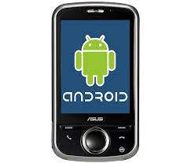

**Advantages of the proposed System:**

We are able to track the patient along with his/her current health status like as heart monitoring & temperature which play a key factor in our life.

# Hardware & Software Components

* 1. **Hardware** 
     1. Raspberry Pi 2 - 1
     2. GPS trans receivers -2
     3. RFIDs -2
     4. Heart rate monitoring sensor
     5. Temperature monitoring sensor
     6. Keyboard
     7. Mouse
  2. **Software**
     1. Linux 2.6
     2. C, C++
     3. Amazon (AWS) services
     4. Shell script
     5. Drivers for GPS, RFID

1. **Conclusion**

We presented an approach for Alzheimer patient tracking using the RFID tags and the GPS. We presented a system allowing having the relative position of the tag. Additionally we described how we can locate using the advantage of each technology. We furthermore present how to fabricate both of the elements: the tag and the reader. Finally, in practical our system can at the same time detect and build accurate maps sending data continually, otherwise knowing the position in real-time of people with Alzheimer disease. We are monitoring temperature, heart beat continuously .Based on the threshold value sms goes to family member and doctor along with location also.

# Future Scope

Further this functionality can be extended to monitor various other parameter of the patient by including other sensors.

**M S Ramaiah Institute of Technology**

(An Autonomous Institute, Affiliated to VTU)

MSR nagar, MSRIT post, Bangalore-54

Project Plan on

**Smart Health Care Monitoring System using Raspberry Pi.**

Under the guidance of

**Mrs. S. Rajarajeswari**

Submitted by

Himanshu Kumar 1MS12CS039

Suhail T N 1MS12CS115

Manoj more S 1MS13CS412

Suresh V 1MS13CS421

*In partial fulfillment for the award of the degree of*

# *Bachelor of Engineering in Computer Science & Engineering*



**DEPARTMENT OF COMPUTER SCIENCE & ENGINEERING**

**M.S.RAMAIAH INSTITUTE OF TECHNOLOGY**

**(Autonomous Institute, Affiliated to VTU)**

**BANGALORE-560054**

[www.msrit.edu](http://www.msrit.edu)

**PROCESS MODEL: AGILE METHOD**

**Abstract:** Software development which can be delivered fast, quick adaptation to requirements and collecting feedback on required information. The agile software methods and development is practices based approach empowered with values, principles and practices which make the software development process easier and in faster time. Agile methods which encompass individual methods like Extreme programming, Feature Driven Development, Scrum, etc are more coming into the commercial and academic worlds.

**Introduction**

Agility refers to the quality of being agile. Internet software industry and Mobile and wireless application development industry are looking for a very good approach of software development. Conventional software development methods have completely closed the requirements process before analysis and design process. As this approach is not always feasible and compatible with all other projects. In contrast to the conventional approaches, agile methods allow developers to make late changes in the requirement specification document.

The focus of the agile software development as given by “Agile Software Development Manifesto” is presented in the following:

* Individuals and interactions over processes and tools
* Working software over comprehensive documentation.
* Customer collaboration over contract negotiation
* Responding to change over following a plan

1. There is vital importance of communication between the individual who are in development team, since development centers are located at different places. The necessity of interaction between Individuals over different tools and different versions and processes is very vital.
2. The only objective of software development team is to continuously deliver the working software for the customers. New releases must be produced for frequent intervals. The developers try to keep the code simple, straight forward and technically as advanced as possible and will try to lessen the documentation.
3. The relationship between developers and the stakeholders is most important as the pace and the size of the project grows. The cooperation and negotiation between clients and the developers is the key for the relationship. Agile methods are using in maintaining good relationship with clients.
4. The development team should be well-informed and authorized to consider the possible adjustments and enhancements emerging during the development process.

**Agile methods**

Agile methods are designed to produce the first delivery in weeks, to achieve and early win and rapid feedback. These methods invent simple answers so that change can be less. These also improve design issues and quality as they are based on iteratively incremental method.

What makes a method an Agile?

When the process is:

1. Incremental: Small releases with rapid iterations
2. Cooperative: Customer and developer relationships
3. Straight: The method which is easy to learn and modify with documentation
4. Adaptive: Able to embrace changes instantly

**Different Agile Software Development methods**

1. Extreme programming
2. Scrum
3. Feature driven development

**Extreme programming**

The life cycle of Extreme programming consists of five phases

1. Exploration
2. planning
3. iteration on releases
4. Product ionizing
5. Maintenance
6. Death

Extreme programming is a light weight software methodology for a small to medium sized teams developing software in the rapidly changing requirements situation. XP matches the behavior of successful programmers in the wild

* + Tests
  + Refactoring
  + Evolutionary delivery
  + Incremental planning
  + Less overhead

**Basic principles:**

* Embracing change: change can come at any time. Model should be ready to take it.
* Rapid feedback: Time between action and feedback is less
* Assume simplicity : Initially assuming simplicity of any task and then proceeding according to the solution
* Incremental change
* Quality work

**SCRUM**

The term ‘SCRUM’ originally derives from a strategy in the game of rugby where it denotes “getting an out of play ball back into the game” with teamwork. Scrum concentrates on how the team members should function in order to produce the system flexibly in a constantly changing environment. Scrum is extremely simple model, used by different software companies from long time, which works with existing engineering practices and is scalable and work with common sense which is to say it is very easy.

Scrum process includes three phases

* Pre-game
* Development
* Post-game

**Pre-game phase** includes two sub-phases

Planning and Architecture design

*Planning* includes the development of the required system. A Backlog list is created, which contains all the requirements that are known at that moment. In every iteration the Back log list is updated by scrum team to gain commitment for the next iteration.

*Architecture phase*: In this phase an abstract view of the model is designed by viewing Backlog list.

**The Development phase**: This phase takes care of the different variable like time farm, quality, requirements, recourses, technologies and tools. The system is developed in Sprints. Sprints are the iterative cycles where functionality is developed or enhanced to produce new increments. Each Sprint includes the traditional phases of software engineering

1. Requirements
2. Analysis
3. Design
4. Evolution and delivery

**The Post-game phase** close to release.

* + Roles in Scrum
  + SCRUM master
  + Product owner
  + Scrum Team
  + Customer
  + User
  + Management

**Practices**

**Product Backlog** defines that is needed in the final product based on current know-how.

**Effort estimation** is the iterative process which is concentrated on Backlog list

**Sprint:** It is the procedure of adapting to the changing environmental variables.

**Feature Driven Development**

FDD is agile approach for software development systems. It provides enough structure for large items, emphasis on quality and working software, delivers frequent, tangible results.

Five phases of FDD

* Develop a overall model
* Build a features list
* Plan by feature
* Design by feature
* Build by feature

**Dynamic systems development method**

Dynamic systems development method is the framework of controls for the software development. While developing DSDM systems designers are interested in “edge case” rather than a mere project “ingredient”.

The principles involved in DSDM are

* Active user involvement is imperative.
* Teams must be empowered to make decisions
* Focus on frequent delivery
* Fitness for deliverable is criterion for accepted deliverables
* Iterative and incremental delivery is mandatory
* All changes during development must be reversible
* Requirements must be baseline at high-level
* Testing is integrated throughout the lifecycle
* Collaboration and co-operative approach

**Conclusions**

As we came to know that traditional software development approaches are more mechanistic which concentrate more on Processes, tools, contracts and plans. In contrast to traditional methods, agile methods keep emphasis on interaction, working software, embracing change at any moment of the project, customer relationships. The method can be agile if it is:

* Incremental
* Cooperative
* Straightforward
* Adaptive

“Agile view is more people centric rather than plan-centric.” Agile methods are not defined by a small set of principles, practices and techniques. It creates a strategic capability which has capability of responding to change, capability to balance the structure and flexibility, capability of innovation and creations through development team and uncertainty.

We have also discussed about different Agile Software development models such as

* XP (Extreme programming)
* Scrum
* FDD (Feature driven development)
* DSDM (Dynamic systems development method).

**EFFORT ESTIMATION USING COCOMO MODEL**

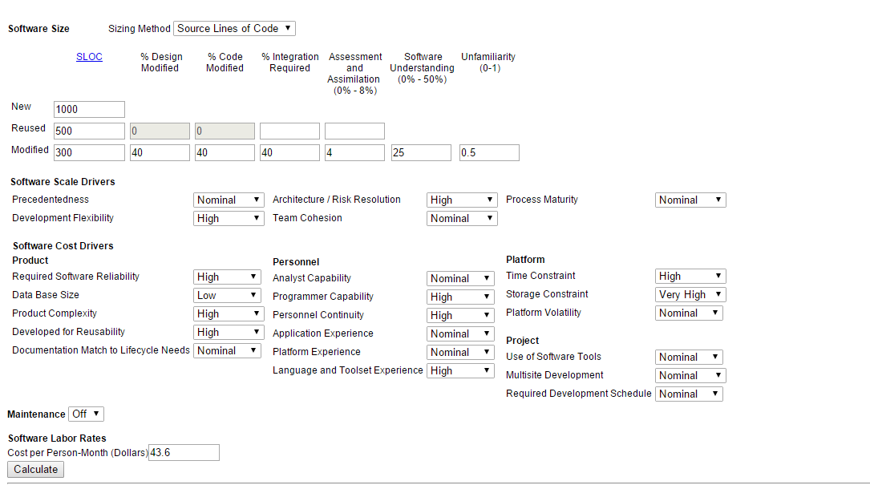

**Figure 3. Online COCOMO Model Page1**

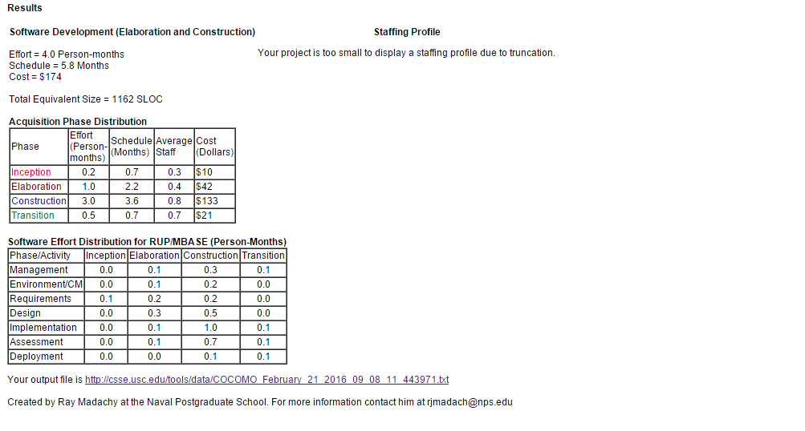

**Figure 4. Online COCOMO Model Page2**

**RISK IDENTIFICATION AND MITIGATION**

**INTRODUCTION**

Risk is denned as an exposure to the chance of injury or loss. That is, risk implies that there is a possibility that something negative may happen. In the context of software projects, negative implies that there is an adverse eject on cost, quality, or schedule. Risk management is the area that tries to ensure that the impact of risks on cost, quality, and schedule is minimal. Risk Mitigation, within the context of a project, can be defined as a measure or set of measures taken by a project manager to reduce or eliminate the risks associated with a project. Risks can be of various types such as technical risks, monetary risks and scheduling-based risks. The project manager takes complete authority of reducing the probability of occurrence of risks while executing a project.

|  |  |
| --- | --- |
| **Possible Risk Factors That May Arise during Any Project’s Evolution** | |
| Life Cycle Stage | Possible Risk Factors |
| All | You or your team spends insufficient time on one or more stages. |
|  | Key information isn’t in writing. |
|  | You or your team moves to a subsequent stage without completing one or more of the earlier stages. |
| Starting the project | Some background information and/or plans aren’t in writing. |
|  | No formal benefit-cost analysis has been done. |
|  | No formal feasibility study has been done. |
|  | You don’t know who the originator of the project idea is. |
| Organizing and preparing | People unfamiliar with similar projects prepare your project plan. |
|  | Your plan isn’t in writing. |
|  | Parts of the plan are missing. |
|  | Some or all aspects of the plan aren’t approved by all key audiences. |
| Carrying out the work | People on the project team didn’t prepare the plan. |
|  | Team members who didn’t participate in the development of the project plan don’t review it. |
|  | You haven’t made an effort to establish team identity and focus. |
|  | You haven’t developed any team procedures to resolve conflicts, reach decisions, or maintain communication. |
|  | Needs of your primary clients change. |
|  | You have incomplete or incorrect information regarding schedule performance and resource expenditures. |
|  | Project-progress reporting is inconsistent. |
|  | One or more key project supporters are reassigned. |
|  |  |
| Team members are replaced. |  |
|  |  |
| Marketplace characteristics or demands change. |  |
|  |  |
| Changes are handled informally, with no consistent analysis of their effect on the overall project. |  |
| Closing the project | Project results aren’t formally approved by one or more project drivers. |
|  | Project team members are assigned to new projects before the current project is completed. |

**TOP 5 RISK ITEMS**

|  |  |  |
| --- | --- | --- |
| **Sl. No.** | **RISK ITEM** | **RISK MITIGATION TECHNIQUES** |
| 1. | Developing the wrong software functions. | Early user manuals, User surveys and developing the software in iterations (prototyping). |
| 2. | Developing the wrong user interface. | Task Analysis, User Characterization, Scenarios and Prototyping. |
| 3. | Updating objectives. | Releasing the software in small increments. |
| 4. | Lack of technical and management skills. | Adequate training and also allocating tasks to people based on their capabilities and strengths, enhanced communication between team members |
| 5. | Use of non effective components. | Clearly understanding the requirements and analyzing the scenarios, requirements scrubbing, cost benefit analysis. |

**M S Ramaiah Institute of Technology**

(An Autonomous Institute, Affiliated to VTU)

MSR nagar, MSRIT post, Bangalore-54

Software Requirement Specification on

**Smart Health Care Monitoring System Using Raspberry pi.**

Under the guidance of

**Mrs. S. Rajarajeswari.**

Submitted by

Himanshu Kumar 1MS12CS039

Suhail T N 1MS12CS115

Manoj more S 1MS13CS412

Suresh V 1MS13CS421

*In partial fulfillment for the award of the degree of*

# *Bachelor of Engineering in Computer Science & Engineering*



**DEPARTMENT OF COMPUTER SCIENCE & ENGINEERING**

**M.S.RAMAIAH INSTITUTE OF TECHNOLOGY**

**(Autonomous Institute, Affiliated to VTU)**

**BANGALORE-560054**

[www.msrit.edu](http://www.msrit.edu)

#### CONTENTS

1. **PRODUCT OVERVIEW**
2. **EXTERNAL INTERFACE REQUIREMENTS** 
   1. User Interfaces
   2. Hardware Interfaces
   3. Software Interfaces
   4. Communication Interfaces
3. **FUNCTIONAL REQUIREMENTS** 
   1. Functional Requirement 1.1
   2. Functional Requirement 1.2
   3. Functional Requirement 1.3
   4. Functional Requirement 1.4
   5. Functional Requirement 1.5
   6. Functional Requirement 1.6
   7. Functional Requirement 1.7
   8. Functional Requirement 1.8
4. **SOFTWARE SYSTEM ATTRIBUTES** 
   1. Reliability
   2. Availability
   3. Security
   4. Portability
   5. Maintainability
   6. Performance
5. **PERFORMANCE REQUIREMENTS**
6. **DATABASE REQUIREMENTS**
7. **DESIGN CONSTRAINTS**
8. **OTHER REQUIREMENTS**
9. **PRODUCT OVERVIEW**

Software development which can be delivered fast, quick adaptation to requirements and collecting feedback on required information. The agile software methods and development is practices based approach empowered with values, principles and practices which make the software development process easier and in faster time. Agile methods which encompass individual methods like Extreme programming, Feature Driven Development, Scrum, etc are more coming into the commercial and academic worlds.

Agility refers to the quality of being agile. Internet software industry and Mobile and wireless application development industry are looking for a very good approach of software development. Conventional software development methods have completely closed the requirements process before analysis and design process. As this approach is not always feasible and compatible with all other projects. In contrast to the conventional approaches, agile methods allow developers to make late changes in the requirement specification document.

The focus of the agile software development as given by “Agile Software Development Manifesto” is presented in the following:

* Individuals and interactions over processes and tools
* Working software over comprehensive documentation.
* Customer collaboration over contract negotiation
* Responding to change over following a plan

1. There is vital importance of communication between the individual who are in development team, since development centers are located at different places. The necessity of interaction between Individuals over different tools and different versions and processes is very vital.
2. The only objective of software development team is to continuously deliver the working software for the customers. New releases must be produced for frequent intervals. The developers try to keep the code simple, straight forward and technically as advanced as possible and will try to lessen the documentation.
3. The relationship between developers and the stakeholders is most important as the pace and the size of the project grows. The cooperation and negotiation between clients and the developers is the key for the relationship. Agile methods are using in maintaining good relationship with clients.
4. The development team should be well-informed and authorized to consider the possible adjustments and enhancements emerging during the development process.

RFID Tag

GPS /GPRS

Raspberry PI 2

Wearable device

Heart Monitor

Temperature Monitor

*Amazon Web* Services

Data Base

Monitor \Laptop



Heart rate and temperature data can be analyzed

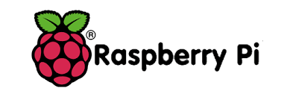

Figure 1. Block Diagram

**2. EXTERNAL INTERFACE REQUIREMENTS**

**2.1 User Interfaces:**

The user interface includes an Android Application. The android application will be highly interactive, efficient, and attractive but would yet be simple and possess a sleek look. Also this interface will be highly user friendly and will perform two important tasks. One task is keeping track of real-time medical related data. Another task is that it would enable the user to keep a location and this would be helpful for analysis and speedy recovery. The remote system displays the voltage value that is produced as the output by the Raspberry pi 2 for the corresponding sensor inputs .The user interface shall be implemented using Java and a framework like Android Studio. A web application to can be implemented where alerts are triggered to keep the relatives informed in case of emergency events.

**2.2Hardware Interfaces:**

The hardware interfaces will include the need of wireless internet connectivity to send Gmail Alerts in case of unforeseen emergency events and also to update the Web Application. Raspberry pi 2 is the hardware device which is responsible for co-coordinating various activities with respect to the project and is the core component. Further heart rate sensors are used to measure the change in heart rate and its output is fed to the input of the Raspberry pi 2. A wireless module must also be interfaced.

**2.3 Software Interfaces:**

The values are sensed from the heart rate sensors which are then fed to the Raspberry pi 2. An assembly language or python program is written and embedded into it to covert the sensor value to a corresponding voltage value as its output. Further Java and a framework like Android Studio will be used to develop the Android Application and also to send the intended Gmail Alerts to the doctor. Further CSS, HTML5 etc. can be used to develop the Web Application which runs on an Apache Tomcat Server.

**2.4 Communication Interfaces:**

SMTP is the communication protocol used to send Email Alerts to the doctor which uses port number 25. Further for the Web Application HTTP protocol is used which runs on port number 80. Also a Wi-Fi signal is used as the communication interface between the wearable computing kit and the Android Application running on the mobile device of the user and monitoring system.

**3. FUNCTIONAL REQUIREMENTS**

**3.1 Functional Requirement 1.1: Tracking of the Real time location**

The GPSR module will help to keep track of the real time location of the person who is under the monitoring.

**3.2 Functional Requirement 1.2: Email Alert**

In case if emergency condition, The Gmail Alert is sent to the doctor and the concerned guardian.

**3.3 Functional Requirement 1.3: Online Monitoring**

The values sensed by the heart rate sensors can also be monitored online with the help of a web application. This is particularly helpful when the user is alone and others want to monitor his/her status.

**3.4 Functional Requirement 1.4: Android notification**

The user is provided with an Android application interface to keep the alerts and also to be updated.

**3.6 Functional Requirement 1.6: Maintaining History**

The Web Application also maintains a log/history of the sensed values which be accessed at any time.

**3.7 Functional Requirement 1.7: Analysis of Data**

The Analysis of data will give the prediction over the health status , Also Android application can also be used to view the complete analysis of data that has been collected.

**4. SOFTWARE SYSTEM ATTRIBUTES**

**4.1 Reliability:**

The reliability of the product depends on the lifetime of the heart rate sensors and the accuracy of the measurement. As lifetime and accuracy is high the system is reliable. Further the android application would be rigorously tested to ensure that the application does its intended tasks in real time and doesn’t generate fake alerts due to some bugs.

**4.2Availability:**

The basic functionality of the system except the Gmail Alerts and Web Application is always available as long as the device is worn by the user. For Gmail Alerts and Web Application updates internet connectivity is needed.

**4.3Security:**

The scope for security in this product is more over concerned with privacy. Only the authorized phone of the user must be capable of receiving the alerts and more over the data readings stored in the web application must be kept safe and thus authentication and authorization can be added. The system shall not leave any cookies on the customer’s computer containing the user’s password. The web browser shall never display a user’s password. It shall always be echoed with special characters representing the typed characters.

**4.4 Portability:**

One of the features of Java is that it is architecturally neutral i.e. the code is machine/platform independent. Thus the same application can run on different Android phones and its backward compatible with respect to a specific Android phone version. Also the Web application can be accessed from a variety of browsers.

**4.5 Maintainability:**

The Android application needs to maintained and updated in case of any bugs. Updated applications will be free from bugs and also some design oriented changes can be incorporated to make the interface more user-friendly and attractive.

**4.6 Performance:**

The product’s performance is measured in terms of responsiveness, efficiency and user experience. A product with high performance will be delivered. Performance is high if the throughput is high, latency is low, response time is less and system dependability exists. The changes in the angle of the knee joint must be measured with accuracy and also in real time. Performance is also affected by the speed of internet connectivity for updating the web application and also for sending Email Alerts.

**5. PERFORMANCE REQUIREMENTS**

The only way in which systems will meet their performance targets is for them to be specified clearly and unambiguously. It is a simple fact that if performance is not a stated criterion of the system requirements then the system designers will generally not consider performance issues. In order to assess the performance of the product the following are clearly specified:

* **Response Time**- It depends on the Raspberry pi 2 used as it needs to execute the embedded program to convert the sensor value into a voltage signal and then needs to transmit the Bluetooth signal. The response time needs to be low.
* **Workload**- Even if the workload on the system is increased the performance doesn’t degrade as Raspberry pi 2 has 16bit CISC architecture. Raspberry pi 2 is designed specifically for ultra-low power applications enabling customers to build low cost system.
* **Scalability**- The product is highly scalable as it can be worn by various users and all that they need to do is to install the Android application on their phone.
* **Platform-** The Raspberry pi 2 is that uses 16bit CISC architecture and the Android application is built using Java and a framework like Android Studio.

**6. DATABASE REQUUIREMENTS**

A database is used to provide persistent offline storage as it keeps a log of the values sensed by the heart rate sensors along with the date and time. The database used needs to be a relational database, for example MySQL can be used or we can make use of Amazon web services for persistent storage.

**7. DESIGN CONSTRAINTS**

1. **Space**: The amount of space occupied by the embedded program must be less as it needs to be incorporated into the Raspberry pi 2. Further the android application must be of size less than 100MB.
2. **Application memory Usage**: The amount of memory that is cache as well as main memory used must be low while executing the embedded program. This is to meet the requirements of the Raspberry pi 2.
3. **Budget**: The amount of money that can be spent on the hardware must be less than Rs6000/- so that the price of the overall is quite reasonable.
4. **Application Quality:** The quality of the product must be good and also it must be comfortable to wear it.

**8. OTHER REQUIREMENTS**

1. **Help:** A detailed user manual which is easy to follow must be developed and also an online demonstration of how to use the product must be available.
2. **Android version:** The application developed must be simulated on the latest Android version and also it needs to be backward compatible.

**M S Ramaiah Institute of Technology**

(An Autonomous Institute, Affiliated to VTU)

MSR nagar, MSRIT post, Bangalore-54

Literature Survey on

**Smart Health Care Monitoring System Using Raspberry pi.**

Under the guidance of

**Mrs. S. Rajarajeswari.**

Submitted by

Himanshu Kumar 1MS12CS039

Suhail T N 1MS12CS115

Manoj more S 1MS13CS412

Suresh V 1MS13CS421

*In partial fulfillment for the award of the degree of*

# *Bachelor of Engineering in Computer Science & Engineering*



**DEPARTMENT OF COMPUTER SCIENCE & ENGINEERING**

**M.S.RAMAIAH INSTITUTE OF TECHNOLOGY**

**(Autonomous Institute, Affiliated to VTU)**

**BANGALORE-560054**

[www.msrit.edu](http://www.msrit.edu)

**INTRODUCTION**

Monitoring healthcare in current generation is to be given an utmost importance. Diseases are the brutal hurdles to human beneficiary. One amongst the brutal illnesses is the Alzheimer’s and Quadriplegia (paralysis due to which all four limbs are affected). People suffering from Alzheimer’s disease tend to forget everything including their own identity, location and their kith and kin’s and people suffering from Quadriplegia sometimes cannot breathe properly and during this time their heart beat may go low or they may be uncomfortable at this time. In order to minimize the difficulties of people who are suffering from Alzheimer or Quadriplegia, we propose a method to locate such person and tracking vitals such has heart beat and body temperature to ensure better care of patient in critical situation. We achieve the monitoring of health care of affected individuals by an android to show varying heart beat and temperature. The process involves generation of patient heart beat and body temperature using appropriate Sensor that are embedded on the Raspberry pi board. We have also added AWS (Amazon web service), where the data generated are send to the server that is created using EC2 (Elastic compute Generation 2) AWS service and later this stored data is send to the Android Application. Sensors embedded in the environment are used to collect behavior and activity patterns for the purpose of detecting health changes. Early detection is the key to promoting health, independence, and function as people age.

**MAIN BODY**

The people suffering from Alzheimer diseases usually forget everything including about their own identify location and their near and dear people. Hence this project proposed a method to help to locate Alzheimer patients when they venture outdoors. Also in the proposed project the Alzheimer patient health is monitored for BP, heart monitoring, body temperature. Nowadays GPS and RFID tags are available which can be effectively used to locate devices and people easily. This project proposes one of such method to address the lost Alzheimer patients and inform about their locations to near and dear. Also by tracking the health parameters of patients their well being is monitored and timely action can be taken. This method proposes to locate Alzheimer patients using RFID tags and GPS data. For this we propose a prototype of an autonomous and wireless system combining the two technologies that enables getting information’s about the position of Alzheimer patient from the intelligent tag, also warn about his absence. The body parameters like heart beating, body temperature are monitored and reported to doctor and relatives regularly.

In the last years RFID have started to enter the field of tracking. Nowadays RFID is used in RTLS [2] [3] (Real-time location systems) for the location of people suffering from Alzheimer within a specific area. RTLS systems are wireless, with transmitter tags attached to the personnel being tracked. But the limitation comes from the fact that we cannot track someone out of the zone of RFID antenna coverage.

**Real-time locating systems (RTLS)** are used to automatically identify and track the location of objects or people in real time, usually within a building or other contained area. Wireless RTLS tags are attached to objects or worn by people, and in most RTLS, fixed reference points receive wireless signals from tags to determine their location.[[1]](https://en.wikipedia.org/wiki/Real-time_locating_system#cite_note-1) Examples of real-time locating systems include tracking automobiles through an assembly line, locating pallets of merchandise in a warehouse, or finding medical equipment in a hospital.

The phrase cardiac monitoring generally refers to continuous [monitoring](https://en.wikipedia.org/wiki/Monitoring_(medicine)) of the heart activity, generally by [electrocardiography](https://en.wikipedia.org/wiki/Electrocardiography), with assessment of the patient’s condition relative to their cardiac rhythm. It is different from [hemodynamic](https://en.wikipedia.org/wiki/Hemodynamic) monitoring, which monitors the pressure and flow of blood within the circulatory system. The two may be performed simultaneously on critical heart patients. A small monitor worn by an ambulatory patient is known as a [Holter monitor](https://en.wikipedia.org/wiki/Holter_monitor). Transmitting data from a monitor to a distant monitoring station is known as [telemetry](https://en.wikipedia.org/wiki/Telemetry) or [biotelemetry](https://en.wikipedia.org/wiki/Biotelemetry). In the setting of out-of-hospital [acute medical care](https://en.wikipedia.org/wiki/Acute_(medicine)), ambulance services and other [emergency medical services](https://en.wikipedia.org/wiki/Emergency_medical_services) providers utilize heart monitors to assess the patient's cardiac rhythm. Providers licensed or certified at the Intermediate or [Paramedic](https://en.wikipedia.org/wiki/Paramedic) level are qualified to interpret ECGs. The finding of a cardiac dysrhythmia (or for that matter, a [normal sinus rhythm](https://en.wikipedia.org/wiki/Normal_sinus_rhythm)) may give additional information about the patient’s condition or may be a sufficient diagnosis on its own to guide treatment. Treatment for specific cardiac rhythms is guided by [ACLS](https://en.wikipedia.org/wiki/Advanced_Cardiac_Life_Support). Basic [EMTs](https://en.wikipedia.org/wiki/Emergency_medical_technician) are allowed to apply the electrodes and physically operate the monitor but not interpret the rhythm.

The concept is to attach an intelligent tag to the Alzheimer patient, and insert the reader in the exit. In the case he tried to go out, his tag will be read and a message of warning will be send to the person in charge who can get all the information’s from the GPS module in the tag. Accordingly, the Alzheimer patient can be followed because of its location that is already known. If the Alzheimer patient is not in indoor we switch to the GPS, turn it on and begin tracking. The RFID and GPS are attached to the asset for tracking and the position of the asset is recorded at regular intervals. The recorded location data can be stored within a tracking unit, or it may be transmitted to a central location data base, or internet-connected computer, using a cellular (GPRS or SMS) modem embedded in the unit. This allows the asset’s location to be displayed in real time. The temperature sensor attached to the body of the patient will record the body temperature periodically and send to the main receiver controller. The controller will display the temperature along with time in which reading is taken. We are able to track the patient along with his/her current health status like as heart monitoring & temperature which play a key factor in our life.

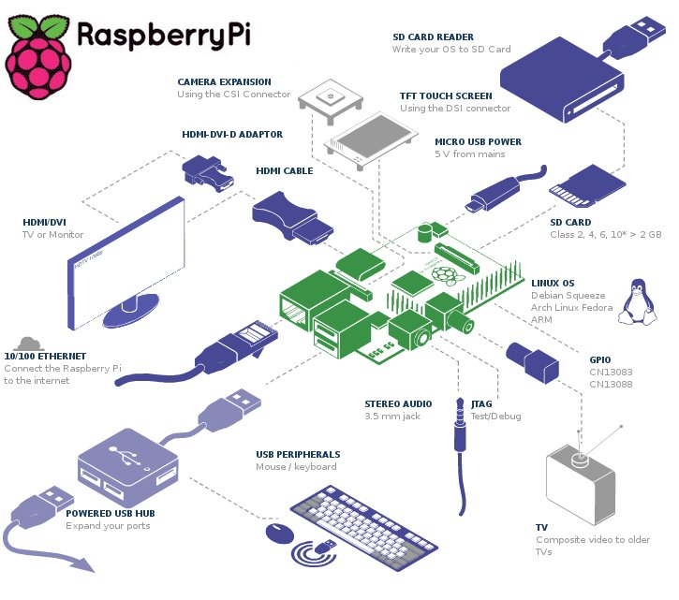

RFID Tag

GPS /GPRS

Raspberry PI 2

Wearable device

Heart Monitor

Temperature Monitor

*Amazon Web* Services

Data Base

Monitor \Laptop



Heart rate and temperature data can be analyzed



**Figure1. Proposed Architecture for monitoring Health Care.**

**CONCLUSION**

The system that we have proposed is light weight and can be used on a daily basis and will help in quick recovery. we presented an approach for Alzheimer patient tracking using the RFID tags and the GPS. We presented a system allowing to have the relative position of the tag. Additionally we described how we can locate using the advantage of each technology. We furthermore present how to fabricate both of the elements: the tag and the reader. Finally, in practical our system can at the same time detect and build accurate maps sending data continually, otherwise knowing the position in real-time of people with Alzheimer disease.

We are monitoring temperature and heart beat continuously .Based on the threshold value sms goes to family member and doctor along with location also. By sending an Email alert to the doctor along with the GPS position of the user it ensures that the user receives immediate care.

**M S Ramaiah Institute of Technology**

(An Autonomous Institute, Affiliated to VTU)

MSR nagar, MSRIT post, Bangalore-54

Design Document on

**Smart Health Care Monitoring System Using Raspberry pi.**

Under the guidance of

**Mrs. S. Rajarajeswari.**

Submitted by

Himanshu Kumar 1MS12CS039

Suhail T N 1MS12CS115

Manoj more S 1MS13CS412

Suresh V 1MS13CS421

*In partial fulfillment for the award of the degree of*

# *Bachelor of Engineering in Computer Science & Engineering*



**DEPARTMENT OF COMPUTER SCIENCE & ENGINEERING**

**M.S.RAMAIAH INSTITUTE OF TECHNOLOGY**

**(Autonomous Institute, Affiliated to VTU)**

**BANGALORE-560054**

[www.msrit.edu](http://www.msrit.edu)

**INTRODUCTION**

Design Document is a document to provide documentation which will be used to aid in software development by providing the details for how the project should be built. Within the Software Design Document are narrative and graphical documentation of the software design for the project including use case models, sequence diagrams, collaboration models, object behavior models, and other supporting requirement information? Design Document is to provide a description of the design of a system fully enough to allow for software development to proceed with an understanding of what is to be built and how it is expected to built. The Software Design Document provides information necessary to provide description of the details for the project and system to be built. Software design is a process to transform user requirements into some suitable form, which helps the programmer in software coding and implementation.

**Modularization**, Modularization is a technique to divide a software system into multiple discrete and independent modules, which are expected to be capable of carrying out task(s) independently. These modules may work as basic constructs for the entire software. Designers tend to design modules such that they can be executed and/or compiled separately and independently. Modular design unintentionally follows the rules of ‘divide and conquer’ problem-solving strategy this is because there are many other benefits attached with the modular design of software.

Advantage of modularization:

* Smaller components are easier to maintain
* Program can be divided based on functional aspects
* Desired level of abstraction can be brought in the program
* Components with high cohesion can be re-used again
* Concurrent execution can be made possible
* Desired from security aspect

**Concurrencies**, Back in time, all software are meant to be executed sequentially. By sequential execution we mean that the coded instruction will be executed one after another implying only one portion of program being activated at any given time. Say, a software has multiple modules, then only one of all the modules can be found active at any time of execution. In software design, concurrency is implemented by splitting the software into multiple independent units of execution, like modules and executing them in parallel. In other words, concurrency provides capability to the software to execute more than one part of code in parallel to each other. It is necessary for the programmers and designers to recognize those modules, which can be made parallel execution.

**Coupling and Cohesion**, When a software program is modularized, its tasks are divided into several modules based on some characteristics. As we know, modules are set of instructions put together in order to achieve some tasks. They are though, considered as single entity but may refer to each other to work together. There are measures by which the quality of a design of modules and their interaction among them can be measured. These measures are called coupling and cohesion.

Thus this document initially describes the different modules present in the project. It is then followed by the algorithms that are used to implement the modules. Later the system architecture is described which is followed by the description of the GUI and then various UML diagrams like class diagram, sequence diagram and data flow diagram are given. Finally, the document ends with the list of references used in developing this document.

The different modules needed and their description for Smart Health Care Monitoring system are given below

1. **Heart Beat Sensor** **Module**: This module is responsible for identifying the change in heart rate, The Heart Beat Sensor provides a simple way to study the heart's function. This sensor monitors the flow of blood through Finger. As the heart forces blood through the blood vessels in the Finger, the amount of blood in the Finger changes with time. The sensor shines a light lobe (small High Bright LED) through the ear and measures the light that is transmitted to LDR. The signal is amplified, inverted and filtered, in the Circuit. Usually Heart rate will be calculated for 1Minute. For a healthy human being we get heart rate of 72 pulse rate per 1 minute. For real time applications we cannot wait for 1minute each time because if there is any disturbance in calculating for ex: if patient is not properly keep his finger inside the device means again we have to take the readings. For this we are following averaging & sampling method. In this we are calculating heart rate for each 5 seconds & we are replacing that value in array of 12 characters. After replacing each value we will add the entire array. After the 12th value we will replace the 13th value on the 1st array element so that we will get average heart rate value for 1 minute. For 5second approximately we get rating of 6.
2. **Raspberry pi 2 model B Module:** Raspberry Pi is a mini computer which is of the size of a credit card . The operating system is called Raspbian OS which is simple and is optimized for Raspberry pi. It’s an open source operating system based on Debian. Once the operating system has been loaded in the Raspberry Pi using the SD card which is of class 10 or higher. The Raspberry pi 2 it has A 900mhz quad-core Arm cortex-a7 CPU, 1gb Ram, 4 USB ports, GPIO 40 pins, Full HDMI port, Ethernet port, Combined 3.5mm audio jack and composite video, Camera interface (CSI),Display interface (DSI),Micro SD card slot ,Video core 1v3d graphics core.
3. **Temperature Sensing Module (LM35):** The LM35 series are precision integrated-circuit temperature sensors, whose output voltage is linearly proportional to the Celsius (Centigrade) temperature. The LM35 thus has an advantage over linear temperature sensors calibrated in Kelvin, as the user is not required to subtract a large constant voltage from its output to obtain convenient Centigrade scaling. The LM35 does not require any external calibration or trimming to provide typical accuracies of ±1⁄4˚C at room temperature and ±3⁄4˚C over a full −55 to +150˚C temperature range. Low cost is assured by trimming and calibration at the wafer level. The LM35’s low output impedance, linear output, and precise inherent calibration make interfacing to readout or control circuitry especially easy. It can be used with single power supplies, or with plus and minus supplies. As it draws only 60 µA from its supply, it has very low self-heating, less than 0.1˚C in still air. The LM35 is rated to operate over a −55˚ to +150˚C temperature range.
4. **RFID Module:** Radio-frequency identification (RFID) is an automatic identification method, relying on storing and remotely retrieving data using devices called RFID tags or transponders. The technology requires some extent of cooperation of an RFID reader and an RFID tag. Radio frequency identification (RFID) technology has been in use for several decades to track and identify goods, assets and even living things. Recently, however, RFID has generated widespread corporate interest as a means to improve supply chain performance. Market activity has been exploding since Wal-Mart's June 2003 announcement that its top 100 suppliers must be RFID-compliant by January 2005. Mandates from Wal-Mart and the Department of Defense (DoD) are making many companies scramble to evaluate, select and implement solutions that will make them compliant with their customers' RFID requirements and additional retailers and other large supply chain channel masters are likely to follow suit.
5. **GSM Module:** Global System for Mobile communications (GSM: originally from Grouped Special Mobile) is the most popular standard for mobile phones in the world. Its promoter, the GSM Association, estimates that 82% of the global mobile market uses the standard. GSM is used by over 3 billion people across more than 212 countries and territories. Its ubiquity makes international roaming very common between mobile phone operators, enabling subscribers to use their phones in many parts of the world. GSM differs from its predecessors in that both signalling and speech channels are digital, and thus is considered a second generation (2G) mobile phone system. This has also meant that data communication was easy to build into the system.
6. **GPRS Module:** General Packet Radio Services (**GPRS**) is a packet-based wireless communication service that promises data rates from 56 up to 114 Kbps and continuous connection to the Internet for mobile phone and computer users.
7. **Database Module:** This module’s function is to insert the data into the Android Application and provide persistent storage for all the activities performed by the user and will be helpful when the user/doctor needs to monitor the user’s activities.
8. **Email Module:** This module’s function is to send an Email alert to the intended recipient’s Gmail account along with the current position of the user which is obtained using GPS.
9. **Web Services (AWS):** AWS IoT is a platform that enables you to connect devices to AWS Services and other devices, secure data and interactions, process and act upon device data, and enable applications to interact with devices even when they are offline.
10. **Android Application Module:** This module’s function is to display the Data generated from the various Sensors that are connected to Raspberry pi. Different data such as Heart rate, temperature , location and User unique RFID is are taken into consideration and are notified to the guardian and Doctor .Basically this module gives the overall status of the patient to the intended person

**Algorithm Design**

Input: Raspberry Pi with all the Sensor connections.

Output: Updating Heart Rate Sensor values and Temperature value to AWS and Android Application Module, sending Email Alert and SMS Alerts.

1. R 🡨 Raw data from the Heart Rate sensors.
2. Ra 🡨 P (R) // parsing the raw data to obtain the actual analog voltage values.
3. Rd 🡨 ADC(Ra) //Converting to digital voltage value.
4. Monitor(Rd) /* Displaying appropriate messages and digital voltage value on Monitor. */
5. App 🡨 Rd // Send data to Android Application.
6. Loop (Keep Track of Threshold value Being Sensed)

Send SMS Alert.

Send Email Alert using phone’s Internet with location as attachment.

Buzzer 🡨 ON

1. If (Temperature Exceeds)

Variable1 🡨 Store Time, Date and Location.

Wc++

1. Else IF (Heart Rate Data Exceeds)

Variable2🡨 Store Time, Date and Location.

Wc++

1. Loop back to step 1.

**ARCHITECTURE DESIGN**

A **system architecture** or **systems architecture** is the conceptual model that defines the structure, behavior, and more views of a system. An architecture description is a formal description and representation of a system, organized in a way that supports reasoning about the structures and behaviors of the system.

System architecture can comprise system components, the externally visible properties of those components, the relationships (e.g. the behaviour) between them. It can provide a plan from which products can be procured, and systems developed, that will work together to implement the overall system. The different module present in this project has been described in the introduction. The system architecture is given in Figure1.



**Figure1. Raspberry pi System Architecture**

RFID Tag

GPS /GPRS

Raspberry PI 2

Wearable device

Heart Monitor

Temperature Monitor

*Amazon Web* Services

Data Base

Monitor \Laptop



Heart rate and temperature data can be analyzed



**Figure2. Project Architecture.**

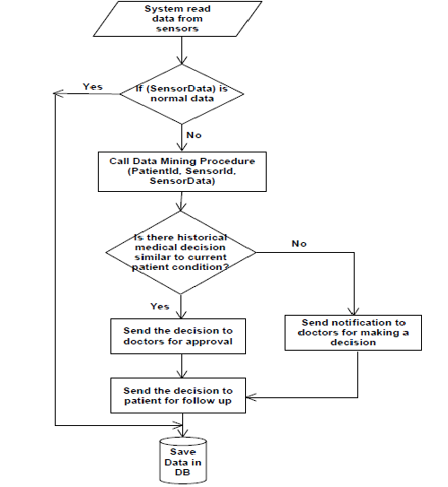

**Figure3. Flow Diagram.**

**GRAPHICAL USER INTERFACE**

The main graphical user interface is an Android Application which communicates with the Raspberry pi board and also which notifies about the patient status. This application initially has a welcome login page for authentication with two buttons, namely login and clear. When the user enters the correct username and the password the login succeeds and redirects the application to the main page shows the graph of user heart rate and temperature. If either the username or the password is invalid, then it prompts the user to enter the correct credentials. Thus the user’s status such as Heart rate, Temperature, Location, RFID can be tracked both on the AWS and cell phone. Further the Android application also all user to look at the location from the Raspberry pi camera and capture the real time picture. The GUI has been planned to designed very efficiently so that it’s user friendly and at the same time has a good look and feel.

Also there is an monitor or laptop which is directly connected to the Raspberry pi board which provides a restricted user interface as it allows the user to only view the data being displayed on it and have complete control over the board using the VNC client module and this VNC control is also available on the Mobile in the form of Android application.

**CLASS DIAGRAM**

Classes are depicted as boxes with three sections, the top one indicates the name of the class, the middle one lists the attributes of the class, and the third one lists the methods. By including both an attribute and a method box in the class I'm arguably making design decisions in my model, something I shouldn't be doing if my goal is conceptual modeling. Another approach would be to have two sections, one for the name and one listing responsibilities. This would be closer to a [CRC model](http://agilemodeling.com/artifacts/crcModel.htm) (so if I wanted to take this sort of approach I'd use CRC cards instead of a UML class diagram). I could also use class boxes that show just the name of the class, enabling me to focus on just the classes and their relationships. However, if that was my goal I'd be more likely to create an [ORM diagram](http://agilemodeling.com/artifacts/ormDiagram.htm) instead. In short, I prefer to follow AM's [*Apply the Right Artifact(s)*](http://agilemodeling.com/practices.htm#ApplyTheRightArtifacts) practice and use each modeling technique for what it's best at.

* In software engineering, a class diagram in the Unified Modelling Language (UML) is a type of static structure diagram that describes the structure of a system by showing the system's classes, their attributes, operations (or methods), and the relationships among objects.
* The figure in the next slide represents the class diagram for wireless temperature monitoring system which uses association, aggregation, composition and generalization and many more features of the class model.
* The relationship among various classes and their interdependencies are effectively modeled using the class diagram.
* The class diagram for this project is shown in Figure4.

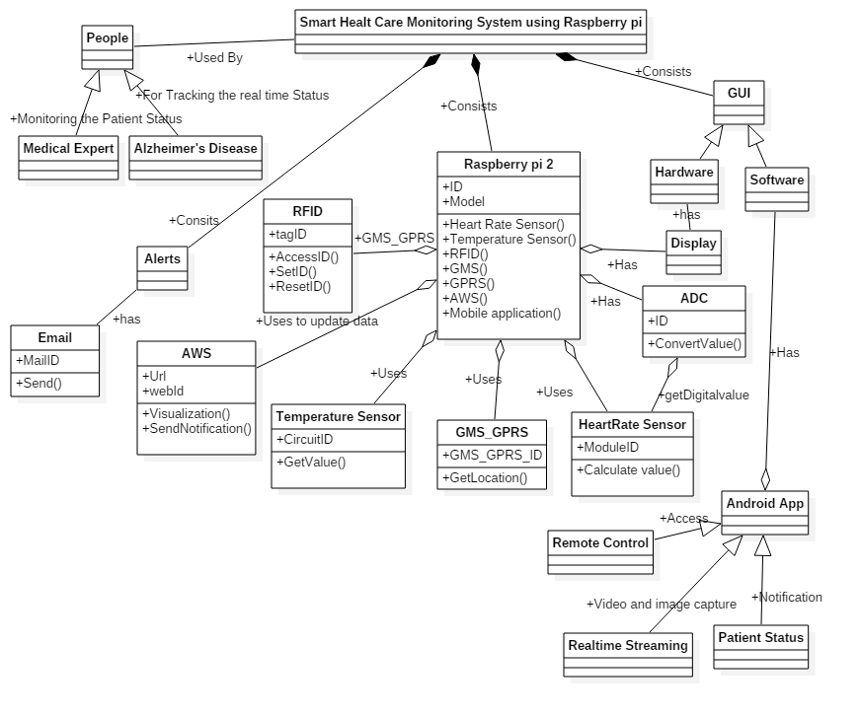

**Figure4. Class Diagram**

**SEQUENCE DIAGRAM**

**Sequence diagram** is an interaction diagram that shows how processes operate with one another and in what order. It is a construct of a Message Sequence Chart. A sequence diagram shows object interactions arranged in time sequence. It depicts the objects and classes involved in the scenario and the sequence of messages exchanged between the objects needed to carry out the functionality of the scenario. Sequence diagrams are typically associated with use case realizations in the Logical View of the system under development. Sequence diagrams are sometimes called **event diagrams** or **event scenarios**.

A sequence diagram shows, as parallel vertical lines (*lifelines*), different processes or objects that live simultaneously, and, as horizontal arrows, the messages exchanged between them, in the order in which they occur. This allows the specification of simple runtime scenarios in a graphical manner. The sequence diagrams for this project are as follows.

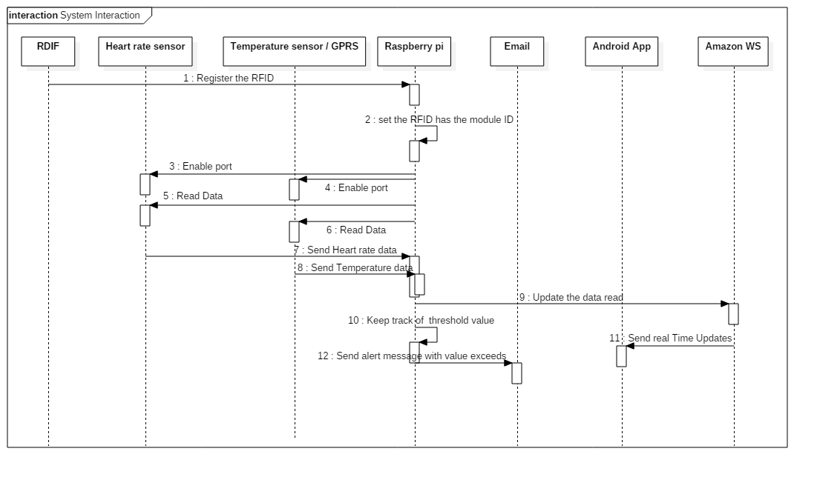

**Figure5. Sequence Diagram for Smart Health Care Monitoring.**

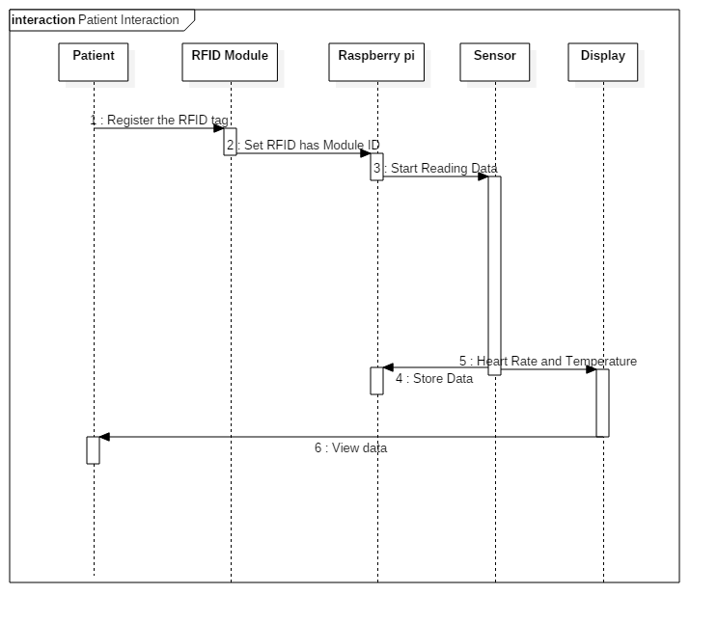

**Figure6. Sequence Diagram for Patient interaction.**

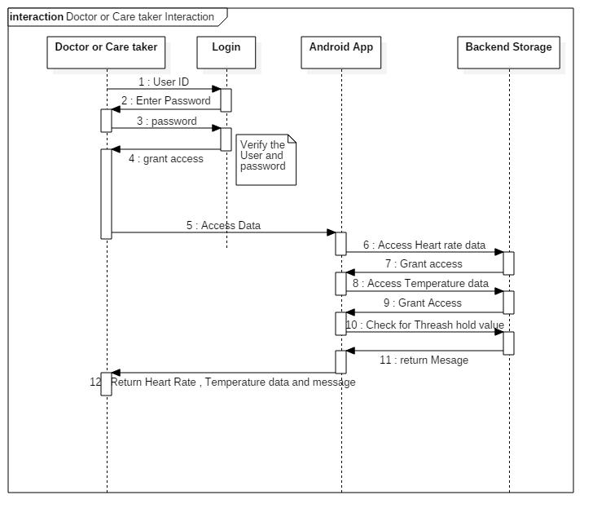

**Figure7. Sequence Diagram for Doctor Interaction.**

**DATA FLOW DIAGRAM**

A **data flow diagram** (**DFD**) is a graphical representation of the "flow" of data through an information system, modelling its process aspects. A data flow diagram (DFD) illustrates how data is processed by a system in terms of inputs and outputs. As its name indicates its focus is on the flow of information, where data comes from, where it goes and how it gets stored. A DFD is often used as a preliminary step to create an overview of the system, which can later be elaborated. DFDs can also be used for the visualization of data processing (structured design).A DFD shows what kind of information will be input to and output from the system, where the data will come from and go to, and where the data will be stored. It does not show information about the timing of process or information about whether processes will operate in sequence or in parallel (which is shown on a flowchart).

Appropriate Domain of Application:

* DFDs are excellent guide for validating the compatibility of the process and designs of the system. This is because in order to design applications successfully, especially large ones, the design of both the processes and the data stores is important. In addition, the data must be consistent with each other. For example, there must be process to store the data in the data stores and the data stores must supply the data views accessed by the processes. Since DFDs depict the relationships between processes, data store, and data views, this made DFD the perfect guide for validating compatibility.
* DFDs are appropriate diagrams for designing high-level application architecture. This is because it is a fact that the larger the application is to be developed the more important the architecture is. For example, building a box does not need an architect but a 10-story building does. In most architectural design, they are represented as diagrams because diagrams are the best way to depict multiple relationships among multiple components. This is applicable to software design, too and DFDs helps tremendously in showing the architecture design of the system r application.
* DFDs are especially useful for depicting system flow charts. DFDs are used to show the flows of data among batch-job steps.

**Untitled Diagram1.png**

**Figure8. Data Flow Diagram.**

**REFERENCES:**

[1] F. Klaus. Radio- Frequency Identification Fundamentals and Applications, New York, 2000.

[2] CNRFID (Centre National de Reference). Available: <http://www.centrenational-rfid.com>.

[3] OAT XERAFY. Available: <http://www.xeraf)r.com/userfiles>.

[4] Alzheimer's Foundation of America, "Lost and . . . Found", America, June.2012.

[5] Adriano. Available: http//www. arduino.cc/.

[6] F43 M4 Dry Inlay Data Sheet, Jump Technology Inc., America, 2013.

[7] 15_23_IEEE_Automated Health Alerts Using In-Home Sensor Data for Embedded Health

Assessment.

[8] 15_27_IEEE_Wireless Sensor Network System using Raspberry Pi and Zigbee for

Environmental Monitoring Application.

[9] 15_33_IEEE_A Smart System Connecting e-Health Sensors and the Cloud.

[10] [www.draw.io](http://www.draw.io)

[11] [www.raspberrypi.org](http://www.raspberrypi.org)

[12] Python Software Foundation [US],  [online] Available: <https://pypi.python.org/pypi>

[13] Pi Raspberry   [online] Available: <http://en.wikipedia.org/wiki/Raspberry_Pi>

[14] Shan and M. Richardson Getting *Started with Raspberry pi*, 2012 :O'Reilly Media, Inc

[15] [online] Available: http://www.raspberrypi.org/products/model-b-plus/